Experiment 6

Aim:
To study and Implement Storage as a Service using Own Cloud/ AWS S3, Glaciers/ Azure Storage. (AWS Academy).

Theory:-
Cloud storage is a service model in which data is maintained, managed, and backed up remotely and made available to users over a network (typically the internet). It allows users to store and access their data and files from anywhere with an internet connection, eliminating the need for physical storage devices. Cloud storage providers, such as Amazon Web Services (AWS), Microsoft Azure, and Google Cloud Platform, maintain large-scale data centers where user data is stored securely.
Cloud storage offers several advantages over traditional on-premises storage solutions:
  - Accessibility: Users can access their files from any device with an internet connection, enabling seamless collaboration and remote work.
  - Scalability: Cloud storage solutions offer virtually limitless scalability, allowing users to increase or decrease storage capacity on-demand without the need for hardware upgrades.
  - Redundancy and Backup: Data stored in the cloud is often replicated across multiple data centers, providing redundancy and ensuring data durability. Additionally, many cloud storage providers offer automated backup solutions, reducing the risk of data loss due to hardware failure or other disasters.
Types of Cloud Storage:
- Object Storage:
  - Object storage is a storage architecture that manages data as objects, each containing data, metadata, and a unique identifier.
  - Cloud platforms like AWS S3, Azure Blob Storage, and Google Cloud Storage offer object storage services.
  - Object storage is ideal for storing unstructured data such as photos, videos, documents, and backups.
- Block Level Storage:
  - Block storage involves dividing data into evenly sized blocks and storing each block as a separate entity.
  - Cloud providers like AWS Elastic Block Store (EBS) and Azure Disk Storage offer block-level storage services.
  - Block storage is commonly used for hosting virtual machine disks, databases, and other applications that require low-latency access to data.
- File Storage:
  - File storage provides a hierarchical structure for organizing and storing data in the form of files and directories, similar to traditional file systems.
  - Services like OwnCloud and AWS Elastic File System (EFS) offer file storage solutions.
  - File storage is well-suited for shared file systems, network-attached storage (NAS), and workloads that require file-based access.
- Cold Storage (Archival Storage):
  - Cold storage, also known as archival storage, is designed for long-term retention of data that is accessed infrequently.
  - Services like AWS Glacier and Azure Cool Blob Storage offer cold storage options.
  - Cold storage solutions offer lower storage costs compared to standard storage tiers but may have longer retrieval times.

  - 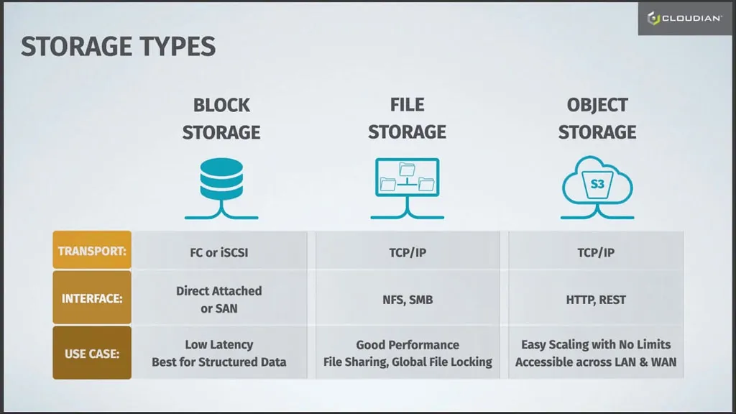

Demonstration:
- Setting Up Cloud Storage:
  - Sign up for an account with a cloud provider and choose the desired storage type.
  - Configure security settings, access controls, and storage options according to your requirements.
- Uploading Files:
  - Upload sample files to the cloud storage service, demonstrating the process of uploading data.
  - Organize files into folders to showcase file management capabilities.
- Accessing and Retrieving Files:
  - Access uploaded files from various devices and platforms to demonstrate accessibility.
  - Compare retrieval speeds for different types of storage, emphasizing performance considerations.
- Testing Cold Storage:
  - Move selected files to cold storage and observe the difference in access times compared to regular storage tiers.
- Exploring Features:
  - Explore additional features such as encryption, versioning, access controls, and sharing options provided by the cloud storage provider.
  - Highlight security and compliance features for data protection and regulatory compliance

CONCLUSION :
In conclusion, cloud storage offers a convenient and scalable solution for storing and accessing data over the internet. Through our demonstration, we explored various types of cloud storage including object, block, and file storage, as well as cold storage options. Each type serves different purposes, with object storage providing versatile storage for diverse data types, block storage offering fast access for applications, and file storage mimicking traditional file systems. Additionally, cold storage options like AWS Glacier and Azure Cool Blob Storage provide cost-effective solutions for archiving data with lower access requirements. Overall, cloud storage empowers users with flexibility, accessibility, and reliability for managing their data needs efficiently.

